Steps 1:-

open google crome

goto to settings

search certificates (Like manage certificates

Link =https://www.youtube.com/watch?v=c6--1GlM6sI&t=22s

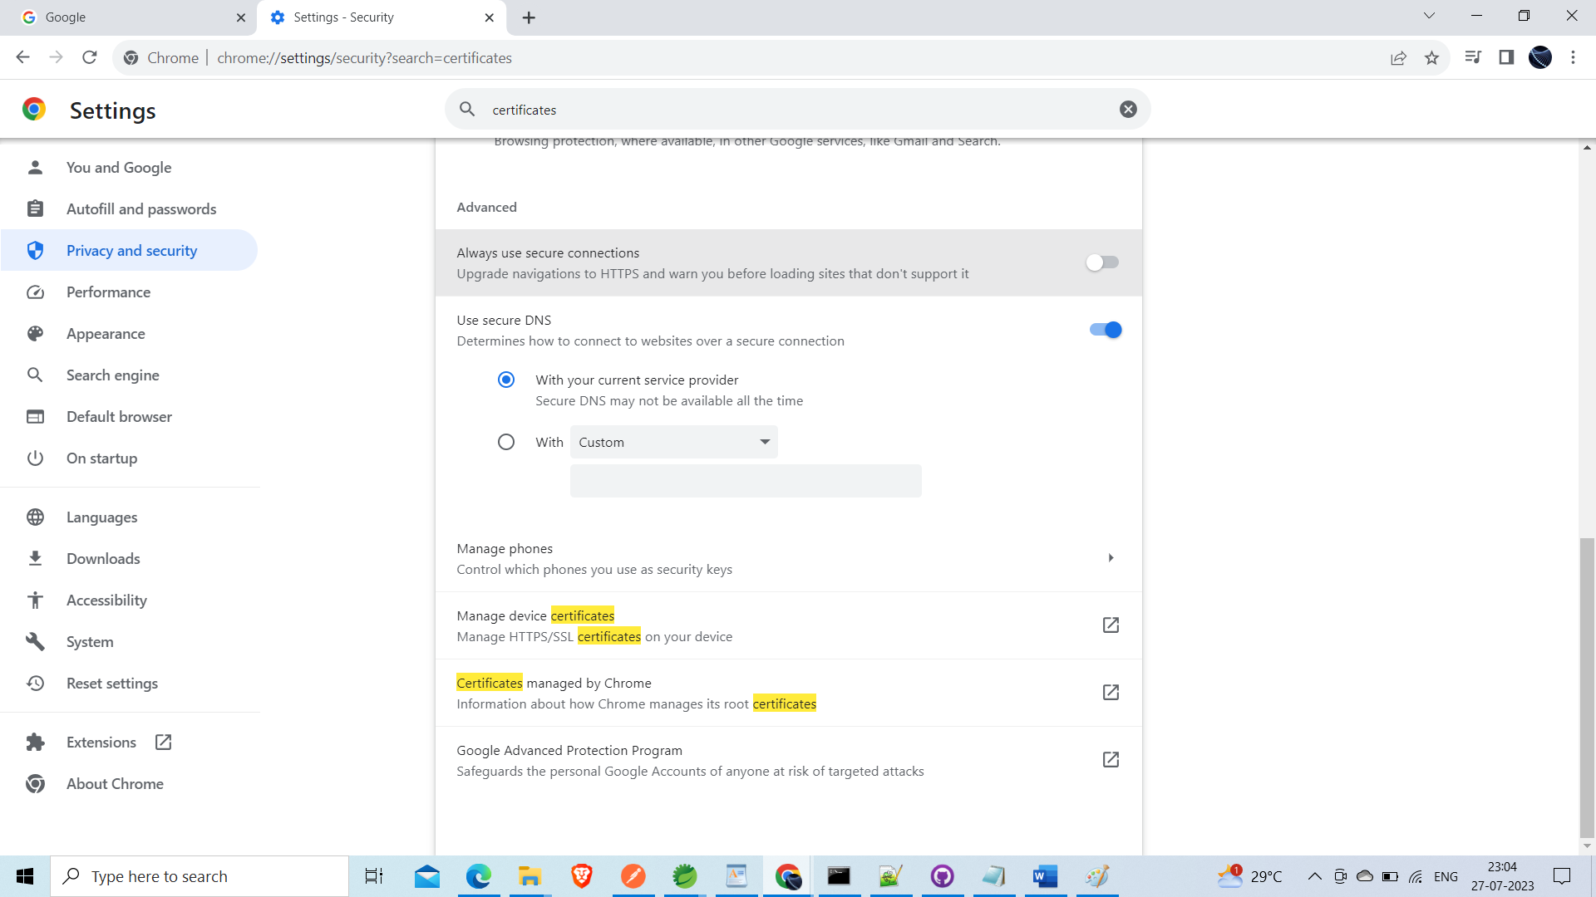

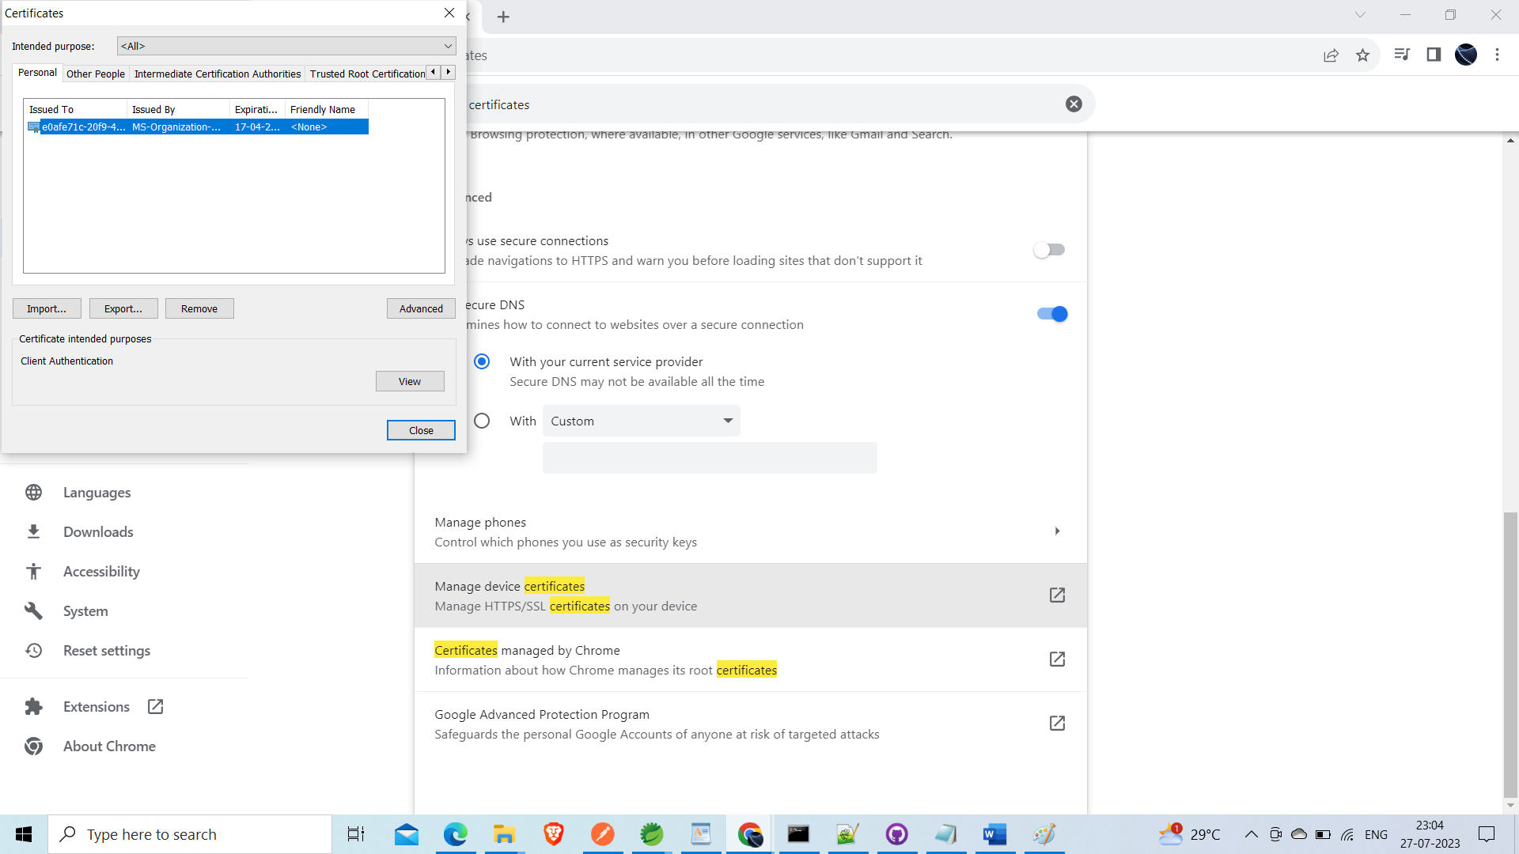

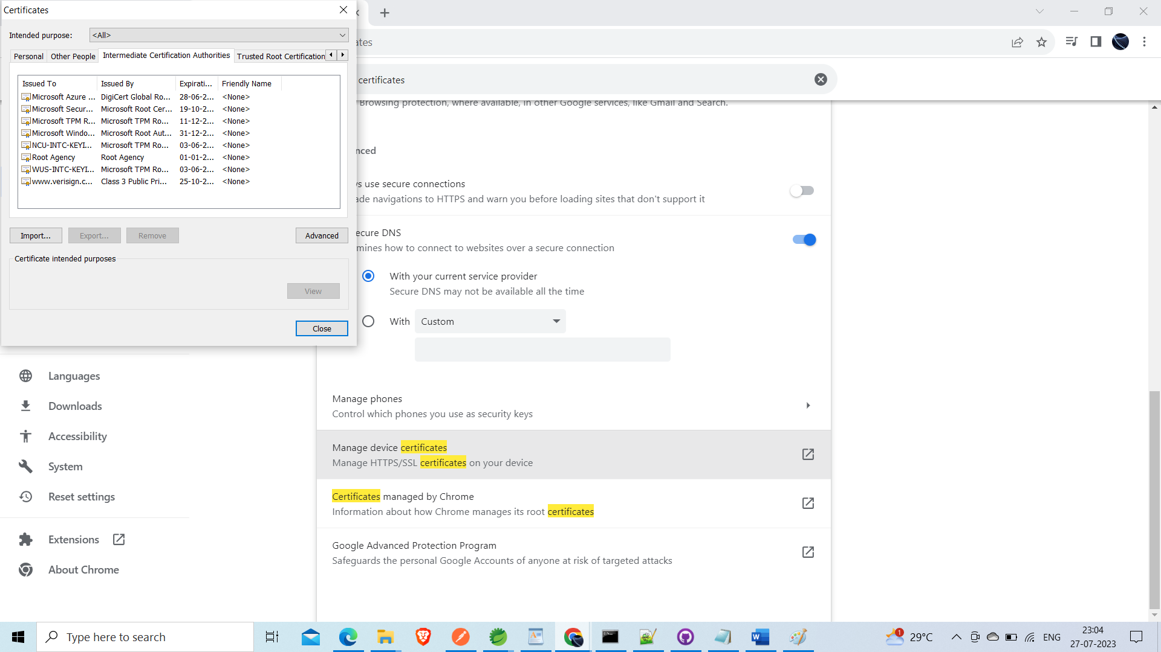

Export certificates

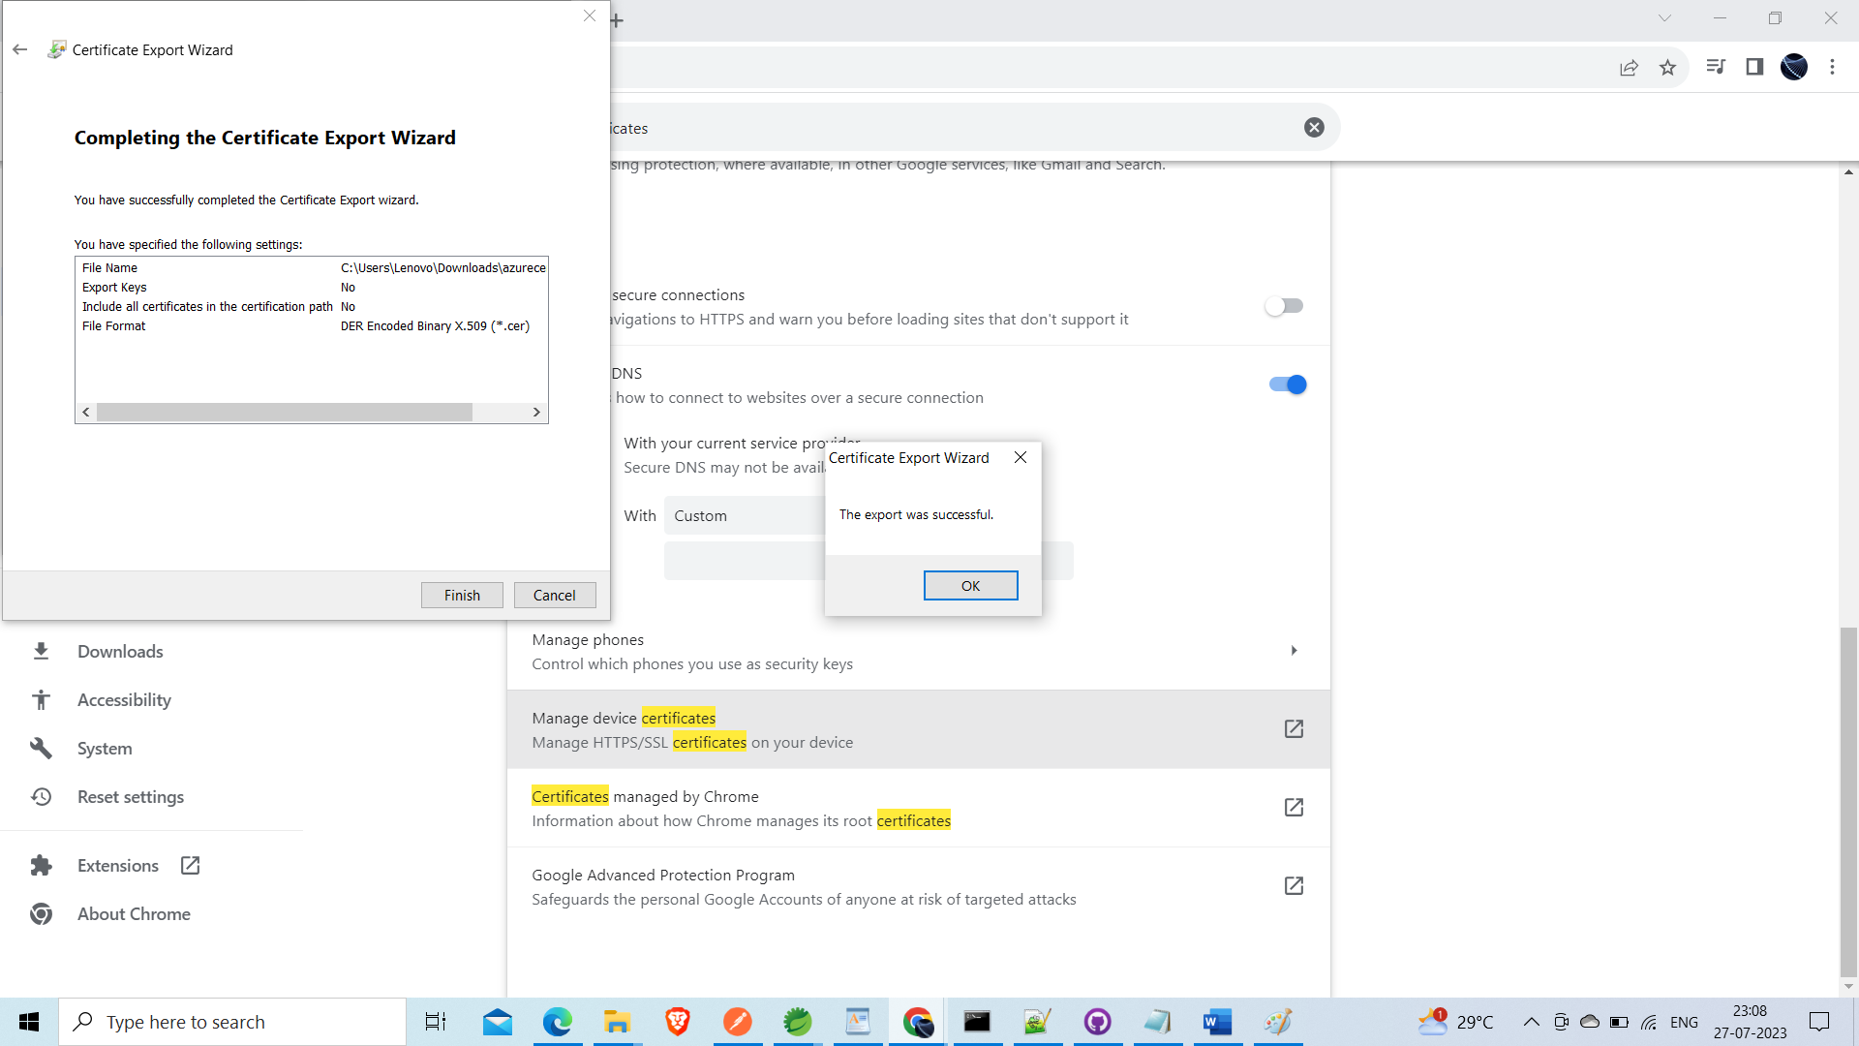

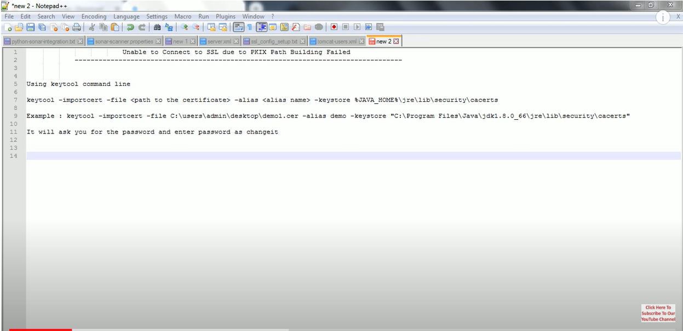

How to export certificate from cmd promt

Open cmd

Steps1

Keytool –help

# Quesetion: PKIX path building failed and Secure Socket Layer Errors - Java connecting to SQL Server

